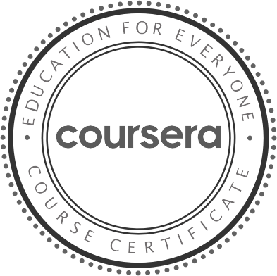

O ct 20, 2023

Potta Ruthwick

has successfully completed

Building Scalable Java Microservices with Spring Boot and Spring Cloud

an online non-credit course authorized by Google Cloud and offered through Coursera

Verif y at: [h ttps://coursera. org/verif y/B 7EC QW 9ERFS 2](https://coursera.org/verify/B7ECQW9ERFS2)

Cour se r a ha s confir me d the ide ntity of this individua l a nd the ir

pa r t icipa t ion in the cour se .



O c t 2 3, 2 02 3

Potta Ruthwick

has successfully completed

Spring - Ecosystem and Core

an online non-credit course authorized by LearnQuest and offered through Coursera

Derek Parsons Instructor LearnQuest

Verif y at: [h ttps://coursera. org/verif y/NHLS 6D T 9K5AV](https://coursera.org/verify/NHLS6DT9K5AV)

Cour se r a ha s confir me d the ide ntity of this individua l a nd the ir

pa r t icipa t ion in the cour se .

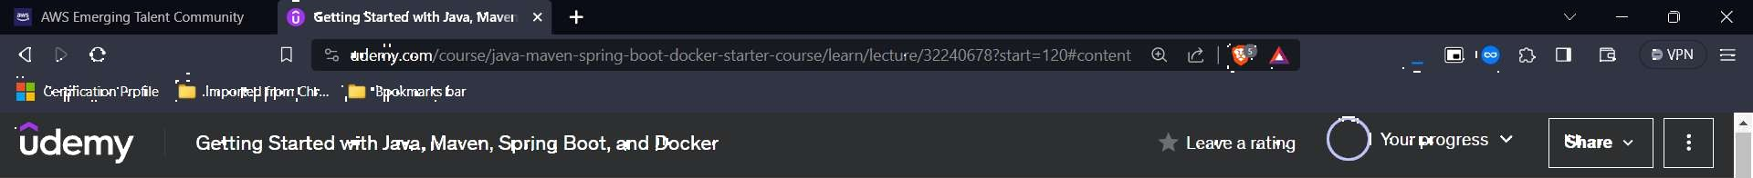



# Congrats on finishing the course!

Would you like to leave a review?

Select Rating

& Course content Overview Notes Announcements Reviews Learning tools 